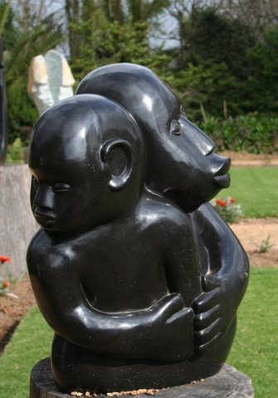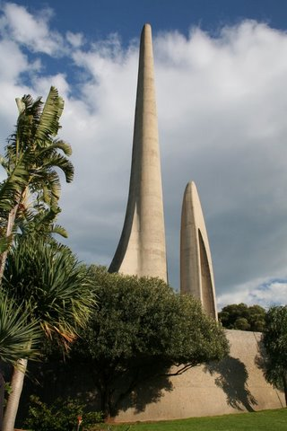

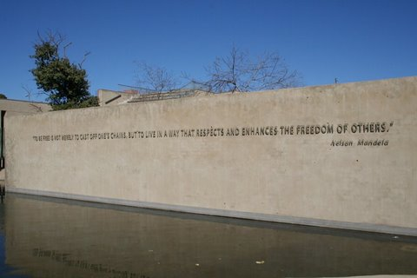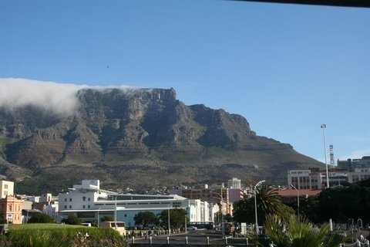

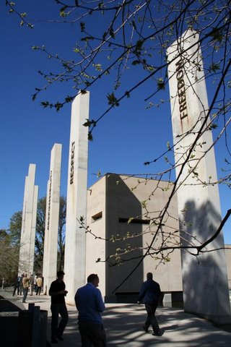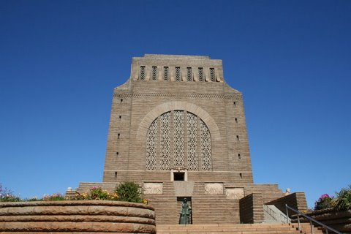

SOUTH AFRICA/NELSON MANDELA

1.
The Africans Language Monument is in Paarl. This is near >Stellenbosch in the Western Cape Province. The monument commemorates the Africaans being declared an official language and therefore independent from Dutch.
Which photo can you associate with this description?
2.
The Voortrekker Monument is in Pretoria and commemorates the Pioneer history and especially the Blyde River Battle against the Dutchmen, where Dingaane (a Zulu despot)lost about three thousand soldiers in 1838
Which photo goes with that monument?
3.
The Apartheid Museum is in Johannesburg. Visiting it gives you goosepimples because it replays continuously the apartheid scenes.
On which photo can you see that museum?

4.
The famous Table Mountain is in Cape Town. This city is in the south and is also the biggest city of the country. It’s harbour is very famous.
On which photo can you see the Table Mountain?
5.
There is a statue which represents two embracing people.
Where can you see that photo?

