Egypt and Tutankhamun

All around the world many people are worried about the situation in Egypt and very sorry also for the pillages that occurred lately at the Egyptian Museum of Antiquity in Cairo.
That museum can be compared with the Louvre in Paris and it contains many very important pieces of ancient Egyptian history.
It houses, for example, the world’s largest collection of Pharaohnic antiquities and the many treasures of the Pharaoh TUTANKHAMUN of the 18th dynasty. The current museum is in Tahir Square where many actual protests are taking place.
It was Howard Carter an English archeologist who is known as the primary discoverer of Tutankhamun’s tomb on 4 November 1922. Carter’s water carrier seems to have found the steps leading to the tomb. It was by far the best preserved and most intact pharaohnic tomb ever found in the Valley of the Kings.
When Carter and his companions arrived they made a „tiny breach in the top left hand corner“ of the door and by means of a candle they could see that the gold and ebony treasures were still in order. Inside the tomb there was a large collection of artefacts, which should accompany the pharaoh to the hereafter. There were weapons, ivory, alabaster and gold bracelets, necklaces or other decorative jewellery. They found the famous chest with the green gem in form of a scarab and with the eye of Horus in the middle and above all the famous GOLD MAKS in the burial chamber. In that room there were murals all over. Carter had never seen anything so magnificent
When Tutankhamun came to power he married his half sister and they had two daughters, both stillborn. During his reign he lifted the ban of Amun (God) and traditional privileges were restored and the capital was brought back to Thebes. like that.
Scientists still do not agree on Tutankhamun’s reason of death. Did he die at the age of nineteen because he was suffering from malaria or maybe because there used to be incest or was he poisoned? However, the latest scans show that he had many broken bones and that one leg got infected. Scientists suppose that he may have fallen from his wagon due to a fight.

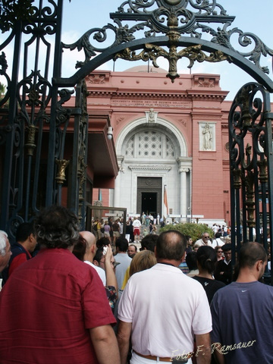

KAIRO
Die ganze Welt schaut in dieser Zeit nach Ägypten und auf die umliegenden Länder und wir sind besorgt, weil der ägyptische Präsident Mubarak nicht zurücktreten will.
Leider ist ja auch das Ägyptische Museum mit den äusserst wertvollen Tutanchamun Schätzen gelündert worden. Dieses Museum beherbert die wichtigste Antiksammlung der Welt. Es kann an Wichtigkeit mit dem Louvre verglichen werden. Ich habe gelesen, dass die eigenen Angestellten des Museums diese Plünderung verursacht haben.
Es sollen auch 2 Mumien zerstört worden sein, sowie Vitrinen mit wervollem Schmuck
eingeschlagen. Das Ägyptische Museum ist im Stadtzentrum am Tahir-Platz und wird nun vermehrt von der Arme beschützt.Die ganzen Schätze sind auch nicht versichert!
nach Ägypten schauen | to look towards Egypt | guardare verso Egitto
zurücktreten | to abdict | dimettersi
wertvoll | precious | prezioso/i
plündern | to pillage | saccheggiare
beherbergen | to house | ospitare
die Antiksammlung | collection of antiquities | collezione di antichitä
die Angestellten | the employees | gli impiegati
zerstören | to destroy | distruggere
beschützen | to protect | proteggere
der Schatz | treasure | il tesoro

