ENGLISH FOR SPECIFIC PURPOSES

By watching my video, you will be informed about the different sectors in which I teach or where I’m together with people who are teachers and that I’m trying to integrate my blog posts into my lessons or give people the opportunity to work on their own at home. E-learning is, however, also a possibility to learn without going to classes. Maybe not everybody will have the money to do that!
To give you some more detailed information about this I could add that the learners in
companies may be in the Board of Directors, lawyers, chemists or, for example people, from the sales or accounting department, information desks or they may be technicians or be responsible for the warehouse.
In the groups where people are trained to become security agents we had all kinds of professions. You can find the Power Point presentation I did for them in category

Sicherhietsdienst/Security Services
http://rivella49.wordpress.com/category/deutsch-mar/sicherheitsdienste

I should maybe also tell you that in Switzerland we serve apprenticeships
that last to four years to become a professional. During this period the trainees do not only go to school but do also work in companies. We are proud of this system which is quite efficient.
Now some points concerning my opinion that it’s certainly not enough to have only technical knowledge of a foreign language to become successful in the professional career. This means , more precisely, that if you are a lawyer or IT specialist and think that that kind of German or English is enough for your job and life, it seems to me a little bit to limited. First of all if you have to lead people you have to have social competences and those can be acquired, of course, by practising, but you have also to understand first that the human being is important. If you want to improve productivity in your company the employees have to be motivated. How do you motivate people? By showing them , for example, what their possibilities are or if you show them perspectives or also mistakes they commit. This makes me know think of the great books by Charles Dickens, such as „GREAT EXPECTATIONS OR CHRISTMAS CAROL“ (You can find summaries of them on my blog) From these books people learn that to become too selfish, and arrogant makes them also very unhappy and unsuccessful and that each person has to work hard to achieve an improvement. So I’m convinced that through literature we learn a lot also about our work life , the others and ourselves(Good films or theatre belong into this category.)
By the way, I’ve been member of a “reading group” for many years and in that group there are several teachers who have probably enlarged the horizon by reading books and can know pass this on to their students .
The situation is similar with travelling or learning about other countries or cultures .
I’ve tried to explain this in the video by speaking about China. I write about other countries because I’ve been there and the photos on my blog are authentic not downloaded from some website and I continue to be interested in what happens around the world. I think we can understand problems or solve them only if we see that they exist. We did the exercises I published about China together with my learners and at the moment we’re reading with some students “BALZAC AND THE LITTLE CHINESE SEAMSTRESS”. Others just read my summary I published on my blog and did the exercise I propose.
I also have a great map (great because it’s a beautiful edition) and we checked on it from where to where the boys in the book were transplanted. I took a photo of the map and
published it on the same page.
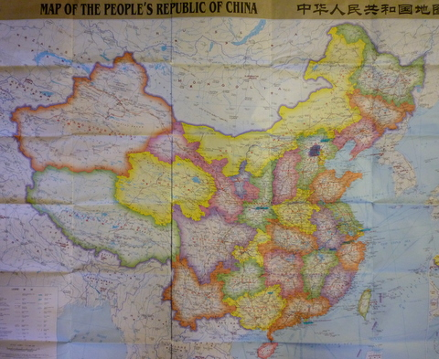

I also speak in the video about the work we have done in our group concerning the terrible disaster in Japan which shocked us very much and makes as sad. For my two chemists in the group it was really very interesting also from their professional point of view. and they explained questions to the other members and me! (There is a post on my blog.)
Yesterday we had the topic food on our program. We had our class book but beyond that I also showed them the exercise about fool on my blog on which they had to complete sentences. A lot of vocabulary turned up and we had a very interesting discussion on wrong mass cultivation around the world which destroys the environment. As the company is trying to do it’s best in order to produce in a environment friendly way this discussion concerned them directly. (In German I’ve just published a very interesting article about WELTHANDEL) However, food is a topic you can always tackle if you go, for example ,out for lunch with a business partner and he my be pleased if you know something about his traditional dishes or behaviour at table. To be a good cook may also give you a possibility to open a SLOW FOOD” restaurant in a foreign country and to be appreciated for that! (The slow food video is in the category BUSINESS on my blog.)
I also teach languages to people in the health sector. As I said for us it is essential for us to be able to communicate with foreigner in our everyday life. In the category health there are also articles for this people.
Last but not least I would also like to point at the fact that I sometimes also add worksheets which can be downloaded and used by teachers in their job.
From time to time I also add a funny video so that we can laugh together and that is also very energy providing, as far as I see it. (I remember the video called “An Italian in Malta” http://rivella49.wordpress.com/2009/12/30/buoni-propositi-per-il-2010 )
These are my points why I believe that what I do can be useful for everybody for their jobs or private life despite the fact that I publish little on specific IT language or other business language.

