From Piotta, in the Leventina Valley,to the Ritom region by the steepest funicular in Europe
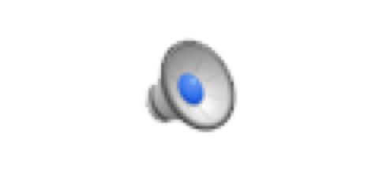It’s really a very special attraction to go up to the Ritom Lake and its uncontaminated and isolated places in the Val Piora by one of the steepest funiculars worldwide.
Audio: Which word is in German?

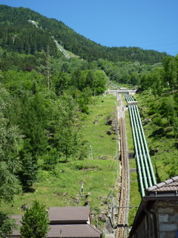

Once up there you have a great choice of excursions or hiking tours. We, for example, just walked around the lake in approximately three hours, picknick inluded.
Audio: Which word is in German?

The other day there was very little water in the lake so that there were sandy beaches I had never seen before. The surrounding was breathtakingly beautiful

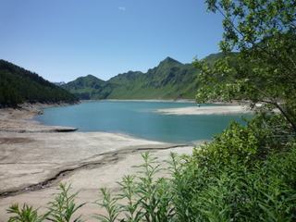

thanks to a big variety of flowers, orchids included.

The railway was built in 1921 and served to transport material and workers needed to
build the dam where water could be stored and then used to operate the very important Gotthard railway. The Ritom power station is still one of the main generators for the Swiss Federal Railways.
Audio: What is missing here?

Click here and you can read an interesting article by Swissinfo.
http://www.swissinfo.ch/eng/Ritoms_waters_power_the_Gotthard.html?cid=4534230

You can now do the drag & drop exercise I’ve prepared for you and correct it online.
http://www.langedi49.ch/RITOM.htm

