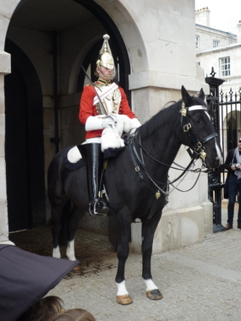
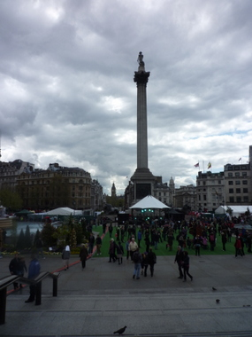1805!

What do you know about the the big fire in 1666? Who lives in Downing Street?
Why are Swiss Clocks so famous?
http://www.youtube.com/watch?v=uCJesLWsak0

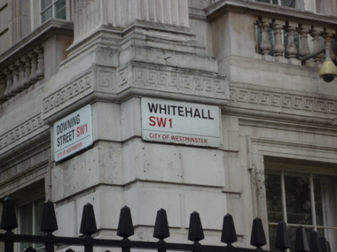
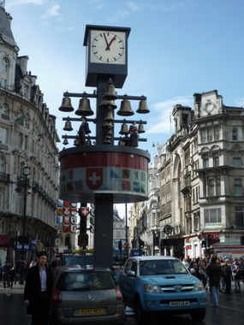
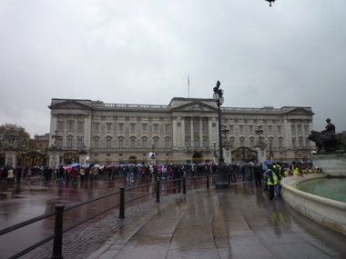

Queen Elisabeth II is Head of State of the UK and 15 other Commenwealth realms.

I should take a ride in a traditional bus if I’m in London.

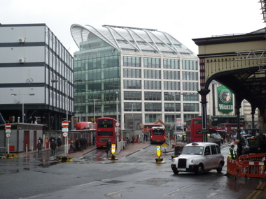

Changing the Guard is very colourful and a „must sees“on a trip to London.

Who was Lord Nelson?
Against whom was the famous battle fought and where did it take place?

