Some days ago I heard about the latest euro-zone member Cyprus to ask a bail-out .
(Rettungsaktion/azione di salvatagio)
This made me think about the beautiful book „BITTER LEMONS OF CYPRUS“ by Lawrence Durrell which I have read some time ago and my trip to Cyprus in 1967.
First of all I would like to give you some information about the island and its history.
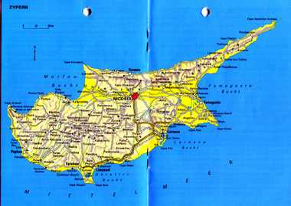

Cyprus is a tiny island in the Mediterranean Sea and its government has been trying
to find the money to recapitalize its second-largest bank.

The demise of Cyprus matters because
-it is has just taken over the presidency of the European Union
-it is now an offender of the Maastricht rules which set a budget-deficit limit
of 3% and not 6.3% as was the case in Cyprus last year.
Question: What’s a bail-out?

Answer:

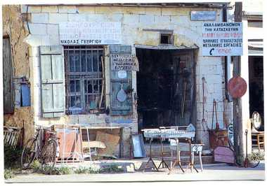

About the history
In the course of history Cyprus was occupied and ruled by many conquerors, among them the Assyriens, Greek, Egyptians, or Persians. In 333 BC Alexander the Great, for example, defeated the Persians and Cyprus became part of the empire . After his death the island got under the Hellenistic state of the Ptolemies of Egypt and later it became part of the Roman Empire.
The Lusignans were among the French nobles who made great careers in the Crusades
and also arrived in Cyprus after having lost the battle against Saladin in Jeruaslem. There were also the Venetians and finally the Ottomans and finally the English which assumed administration of the island in 1878. Between 1955-59 EOKA was created by Greek Cypriots to perform enosis (union of the island with Greece.) This did not happen.
In 1960 Cyprus gained its independence from the United Kingdom,
Internal conflicts turned into full-fledged armed fighting between the two communities on the island which prompted the United Nations to send peacekeeping forces in 1964; these forces are still in place today.
In July 1974 there was a coup by the Military junta then in power in Athens to overthrow president Makarios. Then Turkey launched an invasion against defenseless
Cyprus. Since then part of the island (37%) is under Turkish military occupation and Greek Cypriots, 40% of the latter were forced to leave their homes in the occupied area
and were forced into refugees.

Question: What’s the meaning of defenceless:

Answer:

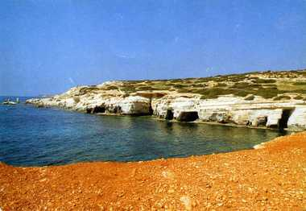

As you can see in the above short summary of Greek’s history, the island has always
been in the hands of different people or empires. This fact may help you to get a broader
consciousness of the Cypriots and enjoy “Bitter Lemons of Cyprus” better. By the way, it is a breathtakingly beautiful autobiographical book but neither is it an easy read nor a history book but much more a book about how the people of various cultures (English, Turks, Greeks) get on together in the 1950’s when the people of Cyprus, egged on by Greece, campaigned for “ENOSIS” and before the eruption of the big chaos.
At the beginning of the story we, the readers, are transferred into a sun soaked setting full up of oranges and pomegranate trees peeking out over the whitewashed village walls. The men sitting under the “Tree of idleness” have coffee and play cards.
The way Lawrence Durrell describes his first contacts with the indigenous just make me laugh. He meets, for example, a priest and speaks in Greek to him which is utterly unbelievable to the latter which would never have expected this from an Englishman. (Page 9-10)
In order to earn some money the writer takes on various jobs- first he teaches English to the kids who will later take part in the occurring violence. Later he also works as an Information Officer for the colonial British government and is dragged into the conflict because of his job, despite the fact that he is not interested in politics. He even sees an assassination scare.
He dreams of buying a cheap village house in Bellapaix, a spectacular place with the loveliest ruined monastery of gothic survival near Kyrenia (Page 48).He sets out on the business with a “Turkish gentleman”. The chapter, which starts at page 38 and in which we, the reader, get into contact with the Cypriotic folk, is just very entertaining and witty.
Afterwards the story moves on to a more serious description of the deterioration of the political and diplomatic situation among the involved parties which all have an interest
in the island. It also seems that the English Foreign Office in London completely underestimated the seriousness of the situation.
Throughout the book we feel the ambivalent feeling the Cypriots have towards the British and on page 270/71 “Dighenis, (“local freedom fighter”) though he fights the British, really loves them-but he will have to go on killing them- we regret- even with affection.”
Why do you think the Cypriots have a “Tree of Idleness?

Answer:

