Kreuzfahrt

VON VENEDIG BIS IN DIE KRIM

"Alle Städte sind gleich, nur Venedig ist ein bissl anders."
- Friedrich Torberg,

Diese Stadt war bis ins 16. Jahrhundert eine der grössten Handelsstädte und bis 1797
Hauptstadt der Republik Venedig. Das Kolonialreich reichte teilweise bis in die Krim und Kaufmannskolonien hatte Venedig z.B. auch in Konstantinopel oder Istanbul. Im 12Jahrhundert wurde Ostrom abhängig von Venedig und je reicher dieses wurde desto ärmer wurde Byzanz.
Venedig soll die herausragendste Industrie im Schiffsbau gehabt haben und z.B. einen höchst effizienten Salzhandel .
Von unserer Position auf dem vorbeiziehenden Schiff hatten wir diese einmalige Möglichkeit Venedig und seine Paläste, die von vergangener Macht dieser Stadt
zeugen, einmal aus einer anderen Perspektive zu sehen und ich muss sagen, wir
fanden das auch ganz toll. Auf dem obigen Foto könnt ihr den Dogenpalast sehen, wo
seit dem 9. Jahrhundert der Sitz der Regierungs- und Justizorgane der Republik
Venedig war. Dieser Palast soll einer der wichtigsten Profanbauten der Gotik
überhaupt sein. Der Markusturm oder Campanile daneben ist das höchste
Gebäude und Symbol der Stadt.
Venedig und Tod werden immer wieder in einem Atemzug gesagt, weil viele Millionen Eichenpfähle seit Jahrhunderten unter den Häusern modern und die Stadt daher dem Untergang geweiht ist. Auch die Verschmutzung durch die vielen grossen Schiffe in der Lagune ist ein enormes Problem.

Ich empfehle euch auch das Didaktisierungstool von Lingo Fox mit ihr Verben trainieren oder konjugieren oder Lückentexte erstellen könnt.
Hier ist der Link: http://lingofox.dw.de/index.php?url=start

Wortschatziste/lista di vocaboli/wordliste
Deutsch | italiano | English
die Handelsstadt | la città commerciale | trading town
das Kolonialreich | l’impero coloniale | colonial empire
abhängig sein | essere dipendente di | to be dependent on
herausragend/ste (Superlativ) | eccellente | outstanding
der Schiffsbau | la costruzione navale | shipbuilding
vorbeiziehen/d | sfilare davanti/sfilando | to pass by/passing by
die Regierung | Il governo | the government
die Verschmutzung | l’inquinamento | pollution
der Eichenpfahl | Il palo di quercia | the oakpale

Hermann Hesse beschreibt Venedig in seinem Gedicht „Ankunft in Venedig“, wie
folgt:
Du lautlos dunkler Kanal,
Verlassene Bucht,
Uralter Häuser graue Flucht,
Gotische Fenster und maurisch
verziertes Portal!
Von tiefem Traum besiegt,
Vom Tode eingewiegt
Schläft hier die Zeit
Und alles Leben scheint so weit, so weit!
Hier will ich ganz allein
Durch alte Gassen gehn,
Bei Fackelschein
An Gondeltreppen stehn,
In blinde Fenster sehn,
Bang-glücklich wie ein Kind im
Dunkeln sein.
Hermann Hesse
In Venedig darf man keine Fragen stellen, sondern soll einfach schauen und
fühlen!
Drei Fragen zu Venedig.

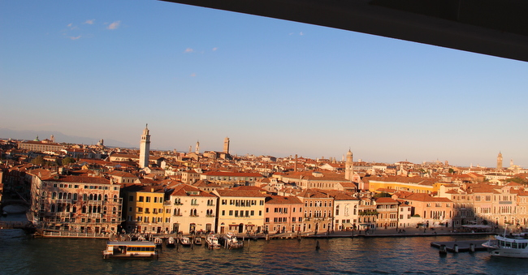

Mögliche Antworten zu meinen Fragen, die ihr euch angehört habt.
1.Wegen den Millionen von Eichenpfähle, die unter der Stadt modern.
2. Venedig ist auch für den Karneval sehr berühmt.
3. In Venedig soll man nicht denken, sondern schauen und fühlen.

Please fill the missing words into the gaps.
Constantinople or Istanbul was the capital city of East Rom or Byzantium and the Ottoman Empire and belongs now to Turkey but is not its capital city 1…………. the fact that it’s probably the best known city of the said country. From the second part of the 11th century onward Constantinople was 2…………………. by the catholic Latin Empires from the West and especially by Venice and from the East by the Seljug Empire.
This city with its magical atmosphere has been built on two continents, Europe and Asia, which are 3. ……………….by the Bosporus Bridge and if you want to go from the Marmara Sea to the Black Sea you have to cross the strait of the Bosporus.
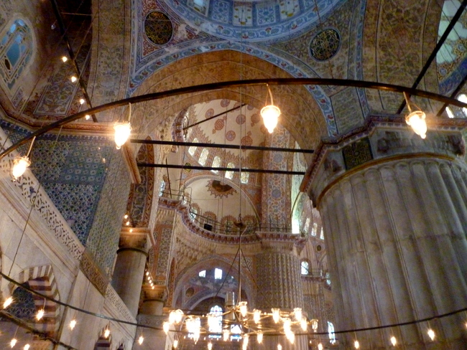
The city has about 15 million inhabitants and to me it seemed that they were all somehow on the streets, in the Tokapi Palace, in the Sultan Ahmed Mosque or in other words The Blue Mosque or in the Hagia Sophia museum. The only free space was the beautiful 4. ………………. fountain. The other day they have opened a new tunnel that goes from one part of the city to the other and there are big hopes that it will help to reduce the caotic traffic situation in Instanbul.
The Blue Mosque was built between 1609-1616 and its popular name comes from the blue and white tiles which adorn the intern walls of the mosque which has 6 minarets. Our guide told us that, these in Iznic produced tiles of 5…………… value, which represent many different flower, fruit or tree designs, are even stolen nowadays and sold at auctions in England. The mosque is still used for prayers. Despite all the people around me it was very touching to admire this marvellous mosque.
1.connected
2.threatened

3.inestimable
4.waterspout
5.despite
We were, in any case, very lucky, because there were no queues when we arrived at the Hagia Sofia, which has been turned into a national museum by the founder of the modern Turkey, Mustafa Kemal Atatürk. who also became the new republic’s first president after the 1st World war which the Ottoman Empire lost and secularized the country. Hagia Sophia is considered the epitome of byzantine architecture and to admire its 6. ………………………. beautiful mosaics is a great pleasure. It seems that it has revolutionized architecture in the sense that it had been the first time in the 6th century that a round dome was placed on a……………………. construction which would probably, however, have collapsed, if the famous Turkish architect SINAN had not added buttresses to sustain the exterior walls in the 16th century.
6.rectangular
7.breathtakingly

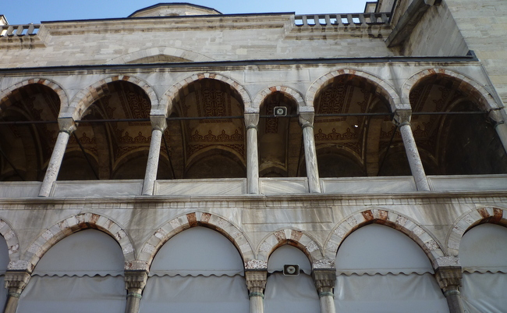

CRIMEA/ODESSA
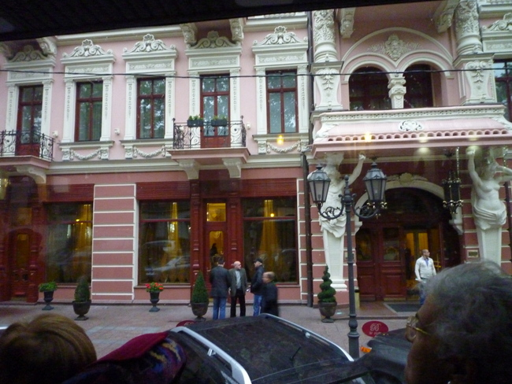
(architectural styles: I think eclectic with new baroque elements)

Catherine the Great made not only war against the Ottoman Empire between 1768-1774
but also invaded and captured the Crimea. She also acquired a right of passage through the straits from Constantinople into the Mediterranean.
I fell, however, in love the at first sight with Catherine the Great’s Odessa, Ukraine which she founded in 1794 and which reminded me of St. Petersburg because of its gorgeous palaces/houses of various architectural styles even in one and the same building and wide streets. or boulevards. Anyway, this city has been multicultural with German colonisations ever since its foundation. Unfortunately in the 30ies, due to intensive and violent russification the society changed completely.
The port is also very impressive and the Potemkin stairs, of course , which are considered a formal entrance into the city from the direction of the sea are the best known symbol of the city and a tourist attraction . Potemkin was Catherine’s co-ruler, lover, secret husband, best friend and one of the most brilliant statesmen of the 18th
century. 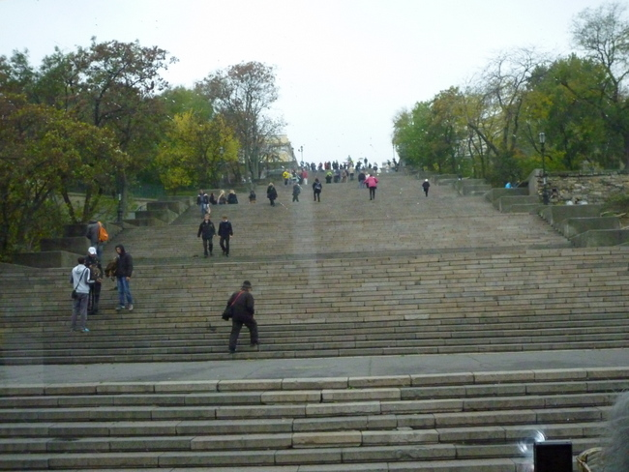
Right behind the stairs, there is also a to the “Duc” de Richelieu. He commanded a division in the Turkish war and after his return to France even became Prime Minister.
There is also a very famous film „Battleship Potemkin“ a classic masterpiece of silent film from director Sergej Eisenstein from 1925 where these stairs are important. The film is based on the true events of the Russian Revolution of 1905. The film had an incredible impact on the development of cinema and was a masterful example of montage editing. http://www.youtube.com/watch?v=7TgWoSHUn8c
At the Prince Gagarin Palace, now literature museum, we could attend a lovely classical concert. Another important building is, of course, the opera in new baroque style or the Tolstoy Palace which also became a museum. I was also looking for the Ephrussi Bank, famous because of the book “ The Hare with Amber Eyes” by Edmund De Waal. It’s right opposite the opera but I couldn’t take a picture but it was grey and didn’t appear to me so outstanding.
The Government and the Pushkin monument are at the southern end of the Primorski Boulevard. The famous writer was exiled to this city in 1823/24 and was forced to work
for the city administration. He wrote more than 30 poems while he was in Odessa and also started with “THE GYPSIES” http://www.pushkins-poems.com/Gypsies01.htm and I like it very much. By the way on the monument you can see that he is showing his behind to the government!

EXERCISE
Lingofox has a special tool into which you can add, for example, a text and indicate
then after how many words you want a gap to appear. I propose that you open the
tool by clicking on the following link
http://lingofox.dw.de/index.php?url=c-test
and then add my summary concerning Odessa into the foreseen window and also add the number of words as said before. Now you click on "Übungsblatt erstellen" or establish worksheet. The tool is in German but I'm sure you will manage it!
When scrolling down the workshheet you can also read the solutions.

